**Sharadchandra Pawar College of Engineering and Technology,**

**Someshwarnagar.**

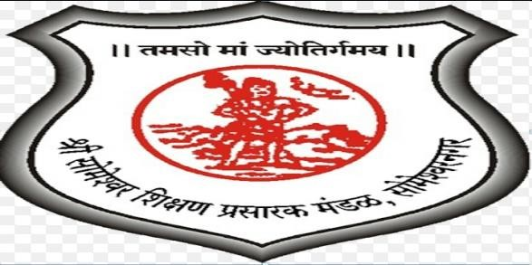

Department of Computer Engineering

A Seminar on :

**“PMPML Route Helper App”**

**Presented by :-**

Bhusha Kadam(CO421)

Yashra Mohite(CO429)

Arbaj Inamdar(CO418)

**Guide Name:-** Mr . Taware G.G.

**“PMPML Route Helper App”**

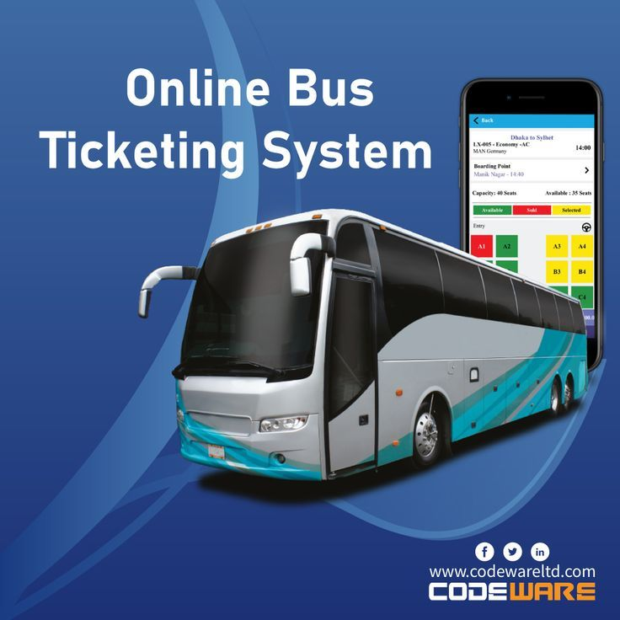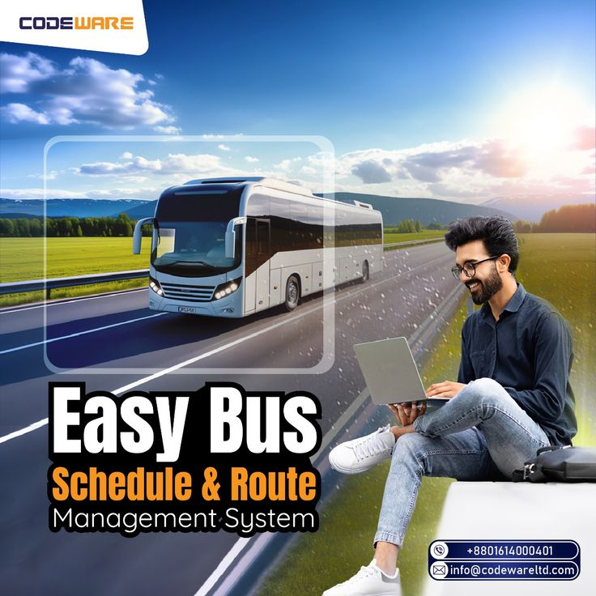

# CONTENT

* Abstract
* Introduction
* Objective
* Literature survey
* Existing System
* Proposed System
* Class Diagram
* Advantages Of Proposed System
* Hardware And Software Requirements
* References

# ABSTRACT

* This project aims to improve public transportation by using digital tools and predictive technology. The current PMPML system struggles with issues like manual ticketing, lack of real-time bus tracking, and poor feedback options, leading to user frustration.
* By creating a smartphone app, offering real-time bus tracking, and improving feedback systems, this project seeks to make public transport more user-friendly and reliable. Additionally, we will implement a bus arrival prediction system to help passengers know when buses will arrive, reducing wait times and making the service more dependable. Overall, this project will make public transport easier to use and encourage more people to choose it, supporting sustainable city living.

# INTRODUCTION

* Public transport plays a crucial role in urban areas by reducing traffic congestion and promoting sustainability.
* Pune's PMPML bus system, although extensive, faces challenges in terms of user satisfaction and reliability, contributing to a low percentage of public transport users.
* As the digital world evolves, integrating technology into public transportation can enhance user experience and efficiency.
* The proposed PMPML Route Helper App aims to modernize the bus system by leveraging digital tools to solve current issues and increase bus ridership

# OBJECTIVE

* The primary goal of the PMPML Route Helper App is to provide user-friendly journey planning, and enhanced wayfinding for first-time and regular users.
* The app aims to improve the reliability, safety, and accessibility of the PMPML system, ultimately encouraging more people to choose public transport as their preferred mode of commuting
* To develop a mobile app that provides users with bus route information, schedules, and can buy tickets online.

# LITERATURE SURVEY

|  |  |  |  |  |
| --- | --- | --- | --- | --- |
| **Sr.No.** | Paper | Author | Contribution | Drawbacks |
| **1**  **2**  **3** | Digitalisation of PMPML Transport System: India  Wayfinding Experience of First-Time Bus Users in Pune  Prediction of Bus Arrival Time Using Real-Time On-Line Bus Locations | Amaan Awati, Sagarika Chadawar, Dr. Ganesh Jadhav, Dr. Suman Devadula, Dr. Sai Prasad Ojha  Madhushree Kulkarni  Chan-Tong Lam, Benjamin Ng, Su Hou Leong | Proposes digital solutions to improve PMPML's efficiency.  Examines challenges faced by first-time PMPML bus users.  Develops a real-time bus arrival prediction system. | Effectiveness may be hindered by poor maintenance.  Small sample size, not broadly generalizable.  Accuracy depends on data quality. |

# 

# EXISTING SYSTEM

The existing PMPML system serves 1.1 million riders daily, but issues such as inconsistent schedules, unclear route information, and low digital integration have led to underutilization.

Current problems include:

* Poor wayfinding tools for new users
* Unreliable bus frequency and overcrowding during peak hours
* Minimal digitalization of ticket booking and feedback processes

# PROPOSED SYSTEM

* The PMPML Route Helper App will incorporate several key features:
* **Journey Planning**: A built-in route planner with an interactive map that suggests the best routes, includes bus transfers, and offers alternatives in case of delays​.
* **Ticketing Integration**: Users will be able to purchase and validate bus tickets digitally, reducing the need for cash handling and physical tickets​.

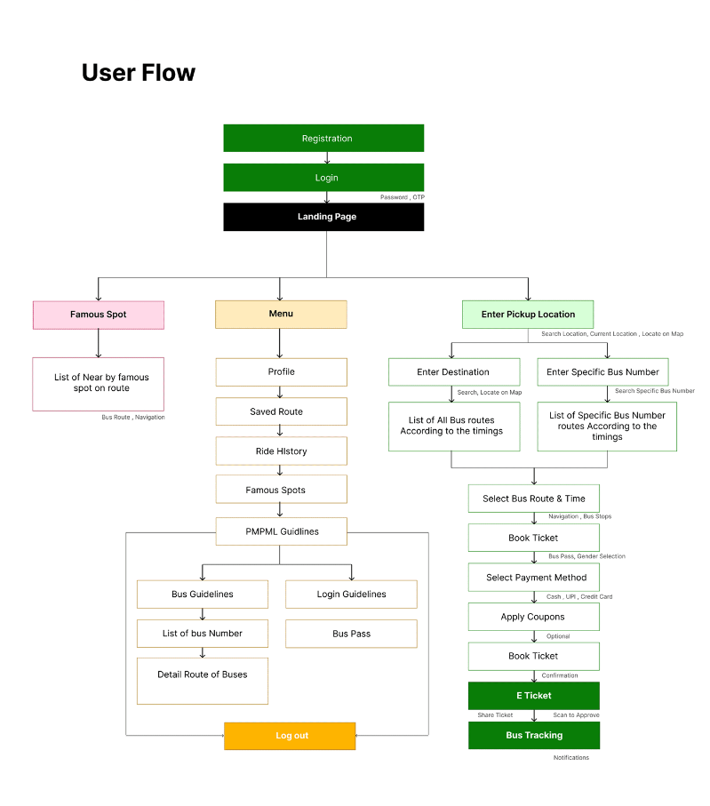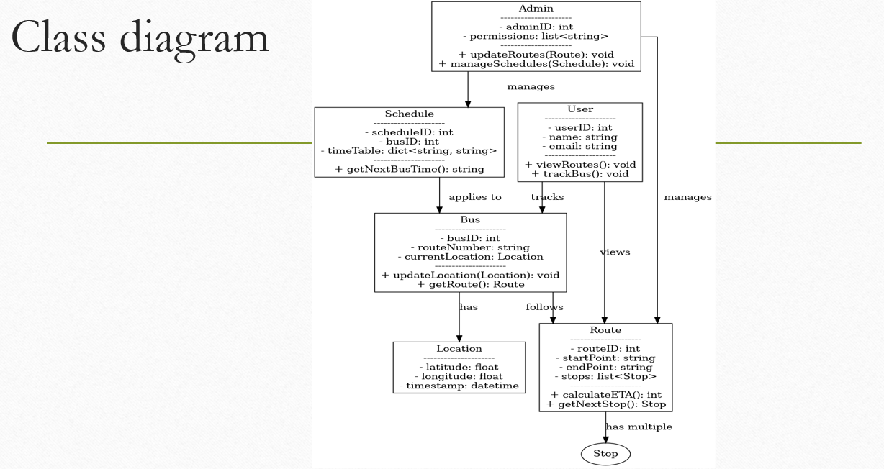

## ADVANTAGES OF PROPOSED SYSTEM

* **Improved User Experience**
* **Increased Ridership**
* **Sustainability**
* **Digital Integration**

# Hardware and Software Requirements

* **Hardware Requirements:**
* **•Memory : Greater than 8GB**
* **•RAM: Greater than 2GB**
* **Software Requirements**:
* **Front End – XML, React**
* **Backend – Corejava , Kotlin , JavaScript**

# REFERENCES

* **Chan-Tong Lam, Benjamin Ng, and Su Hou Leong** - "Prediction of Bus Arrival Time Using Real-Time On-Line Bus Locations," 2019 IEEE 19th International Conference on Communication Technology
* **Madhushree Kulkarni** - "Wayfinding Experience of First-Time Bus Users in Pune," 2023, published in association with Parisar, Pune​
* **Amaan Awati, Sagarika Chadawar, Dr. Ganesh Jadhav, Dr. Suman Devadula, Dr. Sai Prasad Ojha** - "Digitalisation of PMPML Transport System: India," International Journal of Scientific Research in Computer Science, Engineering and Information Technology, Vol. 8, Issue 6, January-February 2022​

Thank You…..